NeuroQWERTY Data Preprocessing Report
The preprocess_neuroqwerty.py implements a robust extraction pipeline for the NeuroQWERTY MIT-CS1PD and MIT-CS2PD datasets, converting raw keystroke timing logs into machine-learning-ready feature vectors.
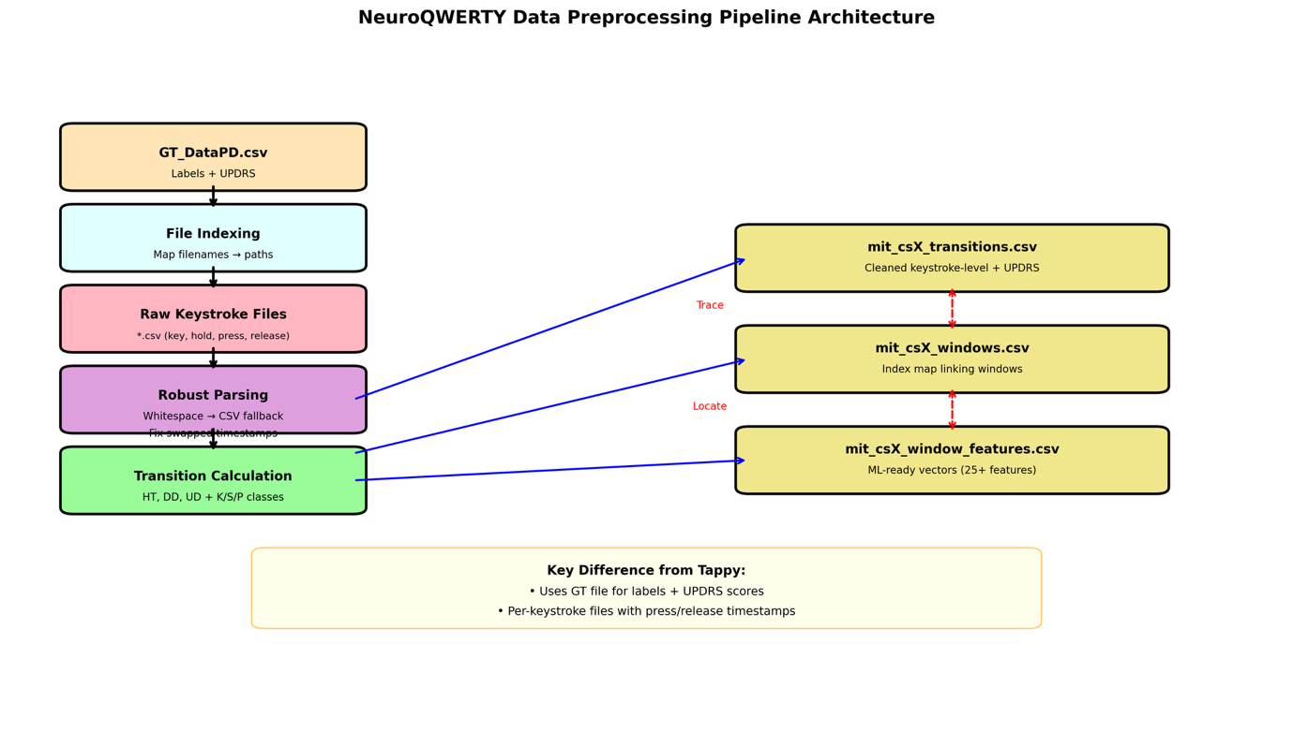
Figure 1: NeuroQWERTY Pipeline Architecture]

Unlike the Tappy dataset, NeuroQWERTY provides per-keystroke files containing press and release timestamps alongside binary Parkinson's disease (PD) labels and UPDRS (Unified Parkinson's Disease Rating Scale) scores in separate ground-truth (GT) files.
Data Ingestion and Parsing. The pipeline begins by indexing all keystroke files in the data directory to ensure reliable path resolution. It reads the GT CSV containing subject identifiers, PD labels (boolean), and UPDRS scores, then locates corresponding keystroke session files listed in columns file_1, file_2, etc. Each keystroke file is parsed robustly: the system first attempts whitespace-delimited parsing, falling back to comma-separated values if needed, and forces exactly four columns (key, hold_sec, press_sec, release_sec). Malformed rows and non-finite values are dropped. Notably, the code detects and corrects swapped press/release timestamps—a common data quality issue—by ensuring chronological order before processing.
Transition Calculation: Raw keystrokes are converted into transition-level metrics analogous to the Tappy dataset but derived differently: Hold Time (HT) is taken directly from the hold_sec field (converted to milliseconds); Digraph Duration (DD) calculates the interval between consecutive key presses; and Up-Down Time (UD) measures the gap between releasing one key and pressing the next.
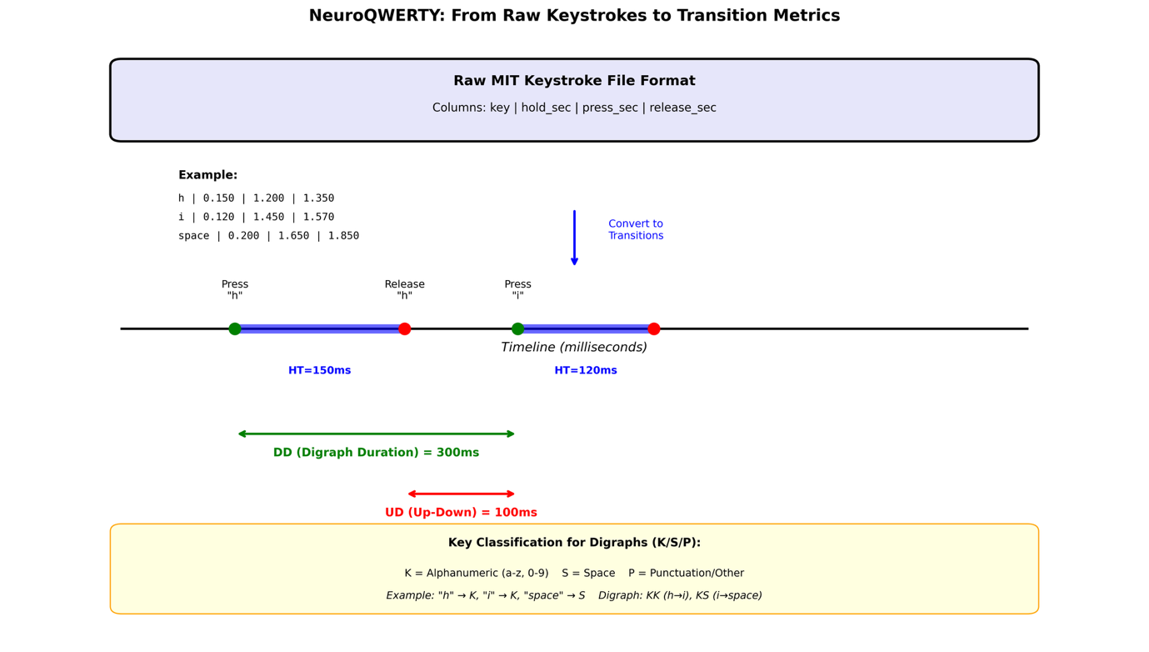
Figure 2: Keystroke to Transition Conversion
Keys are classified into three categories (K = alphanumeric, S = space, P = punctuation) to generate digraph classes (KK, KS, SK, SS, KP, PK, SP, PS, PP), capturing more granular hand-coordination patterns than the binary classification used in Tappy.
Windowing and Feature Extraction: Using a sliding window approach (length = 200 keystrokes, stride = 50, 75% overlap), the pipeline segments continuous typing into analysis units. For each window, it computes statistical descriptors (mean, standard deviation, median, IQR, coefficient of variation, 95th percentile) for HT, DD, and UD. Additionally, pause-rate features quantify the frequency of extended DD intervals exceeding 500ms, 750ms, and 1000ms thresholds—critical for detecting bradykinesia and freezing episodes. Digraph transition rates are calculated for all nine possible key-class combinations.
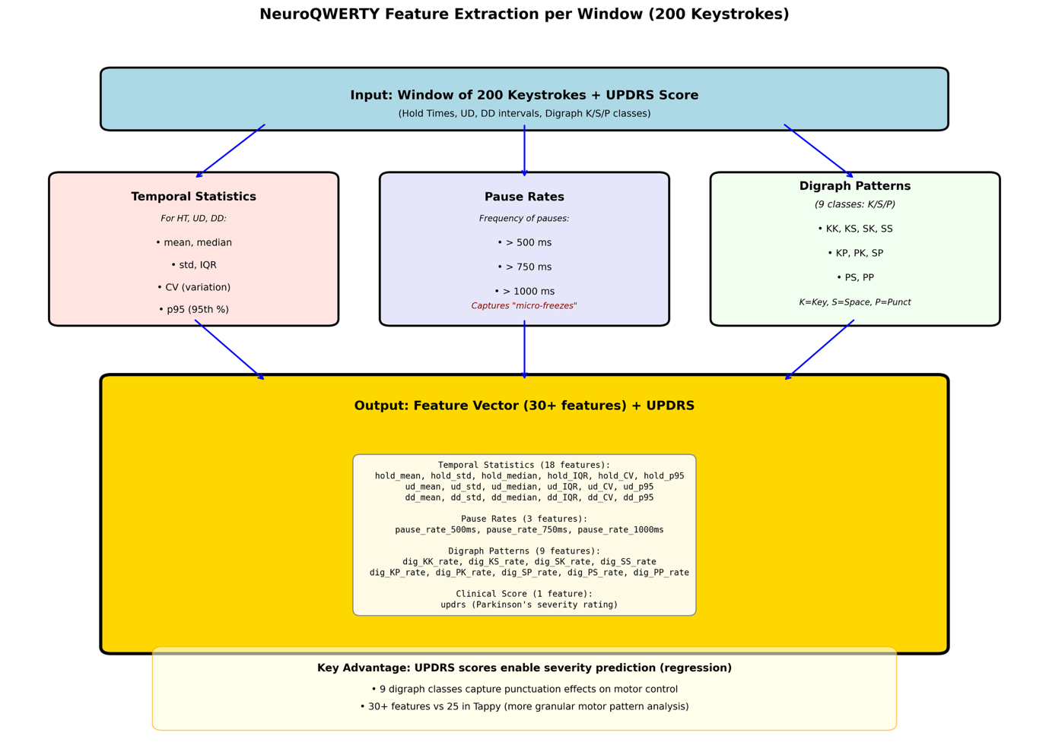
Figure 3: Feature Extraction Schema
Pipeline Outputs The pipeline generates three complementary CSV files: (1) <dataset_tag>_transitions.csv containing cleaned keystroke-level data with UPDRS scores; (2) <dataset_tag>_windows.csv serving as an index mapping each window to specific row ranges in the transitions file; and (3) <dataset_tag>_window_features.csv comprising the final ML-ready matrix where each row represents one window's statistical signature, now enriched with UPDRS severity ratings for regression analysis or stratified classification.

